SOFTWARE TESTING WITH SELENIUM

Task1

**package** day4;

**import** org.openqa.selenium.WebDriver;

**import** org.openqa.selenium.chrome.ChromeDriver;

**import** org.openqa.selenium.chrome.ChromeOptions;

**import** io.github.bonigarcia.wdm.WebDriverManager;

**public** **class** opengoogle{

**public** **static** **void** main(String[] args) {

// **TODO** Auto-generated method stub

// WebDriverManager.chromedriver().setup();

System.*setProperty*("webdriver.chrome.driver","C:\\drivers\\chromedriver.exe");

ChromeOptions co=**new** ChromeOptions();

co.addArguments("--remote-allow-origins=*");

WebDriver driver=**new** ChromeDriver(co);

driver.get("https://demo.opencart.com/index.php?route=account/register&language=en-gb");

}

}

Output

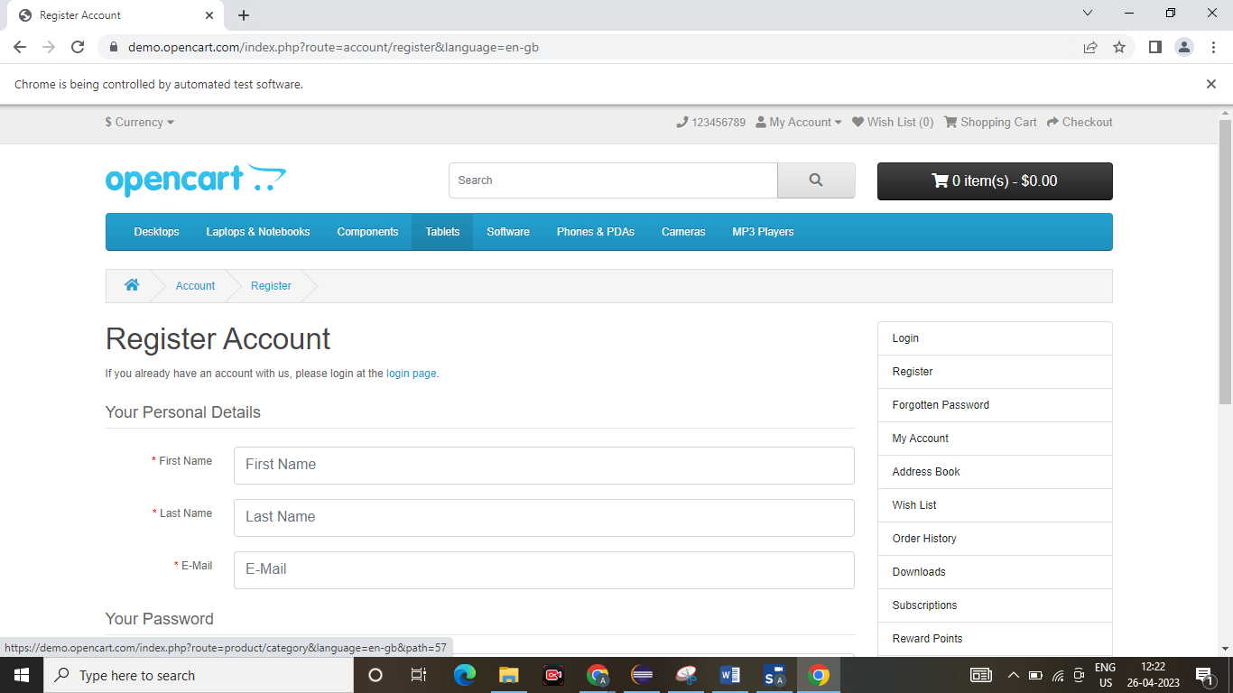

TASK2

package day4;

import org.openqa.selenium.By;

import org.openqa.selenium.JavascriptExecutor;

import org.openqa.selenium.WebDriver;

import org.openqa.selenium.WebElement;

import org.openqa.selenium.chrome.ChromeDriver;

import org.openqa.selenium.chrome.ChromeOptions;

import io.github.bonigarcia.wdm.WebDriverManager;

public class task2 {

public static void main(String[] args) {

// TODO Auto-generated method stub

System.setProperty("webdriver.chrome.driver","C:\\drivers\\chromedriver.exe");

ChromeOptions co=new ChromeOptions();

co.addArguments("--remote-allow-origins=*");

WebDriver driver=new ChromeDriver(co);

driver.get("https://demo.opencart.com/index.php?route=account/register&language=en-gb");

WebElement fname=driver.findElement(By.id("input-firstname"));

fname.sendKeys("ABISREE");

WebElement lname=driver.findElement(By.id("input-lastname"));

lname.sendKeys("D");

WebElement email=driver.findElement(By.id("input-email"));

email.sendKeys("abc@gmail.com");

WebElement pwd=driver.findElement(By.id("input-password"));

pwd.sendKeys("@unique03");

JavascriptExecutor js=(JavascriptExecutor)driver;

js.executeScript("window.scrollBy(0,500)"," ");

WebElement nbutton=driver.findElement(By.id("input-newsletter-no"));

nbutton.click();

}

}

Output:

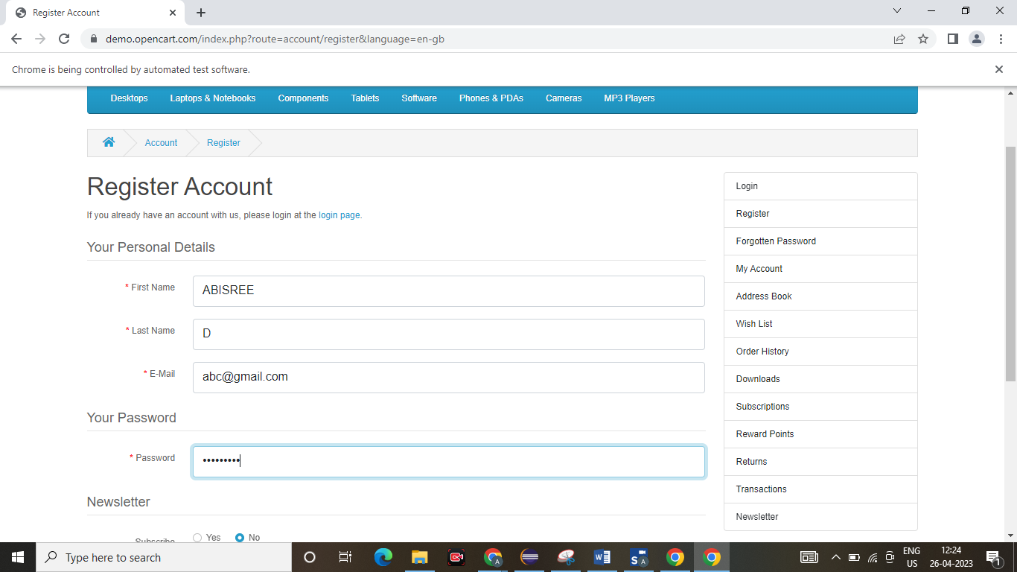

TASK3

package day4;

import org.openqa.selenium.By;

import org.openqa.selenium.JavascriptExecutor;

import org.openqa.selenium.WebDriver;

import org.openqa.selenium.WebElement;

import org.openqa.selenium.chrome.ChromeDriver;

import org.openqa.selenium.chrome.ChromeOptions;

import io.github.bonigarcia.wdm.WebDriverManager;

public class task3 {

public static void main(String[] args) throws InterruptedException {

WebDriverManager.chromedriver().setup();

System.setProperty("webdriver.chrome.driver","C:\\drivers\\chromedriver.exe");

ChromeOptions co=new ChromeOptions();

co.addArguments("--remote-allow-origins=*");

WebDriver driver=new ChromeDriver(co);

driver.get("https://demo.opencart.com/index.php?route=checkout/voucher&language=en-gb");

WebElement fname=driver.findElement(By.xpath("//*[@id=\"input-to-name\"]"));

fname.sendKeys("ABISREE");

WebElement lname=driver.findElement(By.xpath("//*[@id=\"input-from-name\"]"));

lname.sendKeys("D");

WebElement email=driver.findElement(By.xpath("//*[@id=\"input-to-email\"]"));

email.sendKeys("sreearu@gmil.com");

WebElement eemail=driver.findElement(By.xpath("//*[@id=\"input-from-email\"]"));

eemail.sendKeys("dhana@gmil.com");

WebElement button=driver.findElement(By.xpath("//*[@id=\"input-theme-7\"]"));

button.click();

JavascriptExecutor js=(JavascriptExecutor)driver;

js.executeScript("window.scrollBy(0,250)","");

Thread.sleep(3000);

WebElement message=driver.findElement(By.xpath("//*[@id=\"input-message\"]"));

message.sendKeys("Hi!!");

WebElement amt=driver.findElement(By.xpath("//*[@id=\"input-amount\"]"));

amt.sendKeys("1");

WebElement button1=driver.findElement(By.xpath("//*[@id=\"form-voucher\"]/div[8]/div/div/input"));

button1.click();

}

}

Output:

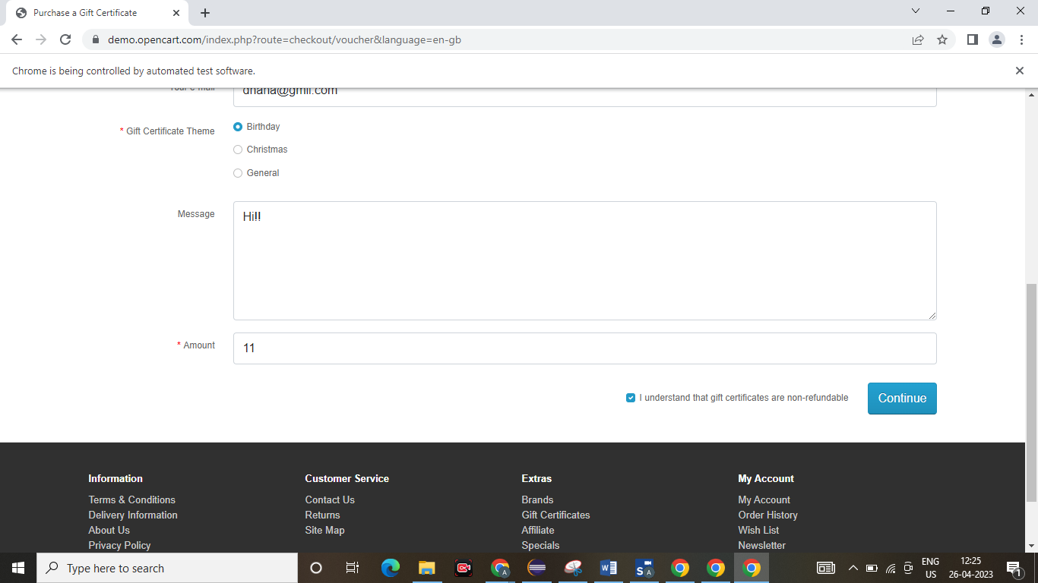

Task4

package day4;

import org.openqa.selenium.By;

import org.openqa.selenium.WebDriver;

import org.openqa.selenium.WebElement;

import org.openqa.selenium.chrome.ChromeDriver;

import org.openqa.selenium.chrome.ChromeOptions;

import io.github.bonigarcia.wdm.WebDriverManager;

public class task4 {

public static void main(String[] args) {

WebDriverManager.chromedriver().setup();

ChromeOptions co=new ChromeOptions();

co.addArguments("--remote-allow-origins=*");

WebDriver driver=new ChromeDriver(co);

driver.get("https://j2store.net/free/");

WebElement clothing=driver.findElement(By.xpath("//*[@id=\"Mod112\"]/div/div/ul/li[1]"));

clothing.click();

driver.manage().window().maximize();

driver.navigate().back();

driver.navigate().forward();

driver.navigate().refresh();

driver.close();

}

}

Output:

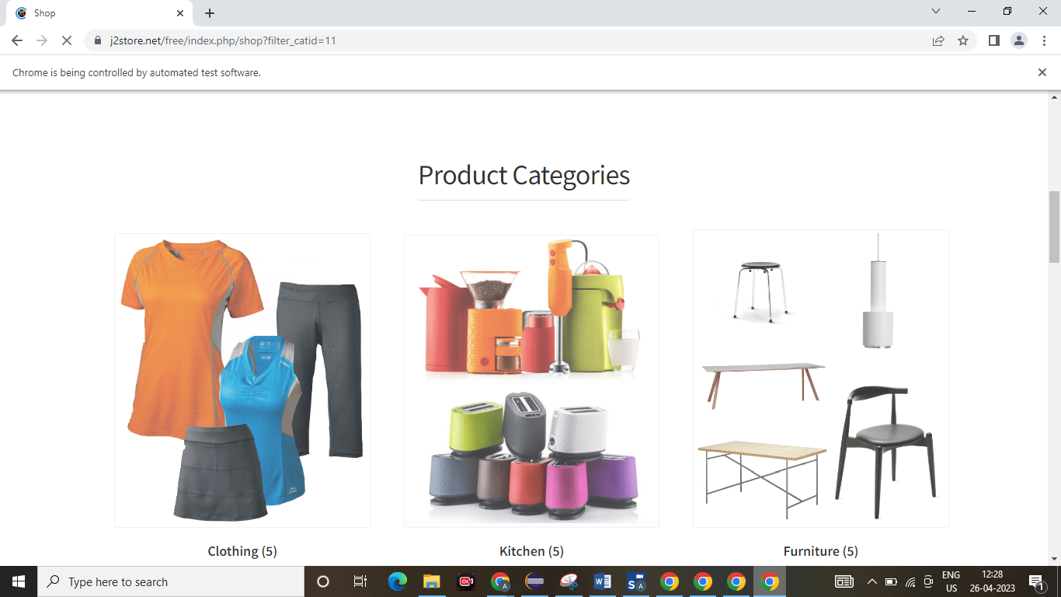

Task5:

package day4;

import org.openqa.selenium.By;

import org.openqa.selenium.WebDriver;

import org.openqa.selenium.WebElement;

import org.openqa.selenium.chrome.ChromeDriver;

import org.openqa.selenium.chrome.ChromeOptions;

public class task5 {

public static void main(String[] args) {

System.setProperty("webdriver.chrome.driver","C:\\drivers\\chromedriver.exe");

ChromeOptions co=new ChromeOptions();

co.addArguments("--remote-allow-origins=*");

WebDriver driver=new ChromeDriver(co);

driver.get("https://j2store.net/free/");

String url1=driver.getCurrentUrl();

if(url1.equals("https://j2store.net/free/"))

{

System.out.println("url validated");

}

WebElement clothing=driver.findElement(By.xpath("//*[@id=\"Mod112\"]/div/div/ul/li[1]/h4/a"));

clothing.click();

url1=driver.getCurrentUrl();

if(url1.equals("https://j2store.net/free/index.php/shop?filter_catid=11"))

{

System.out.println("url validated");

}

}

}

Output:

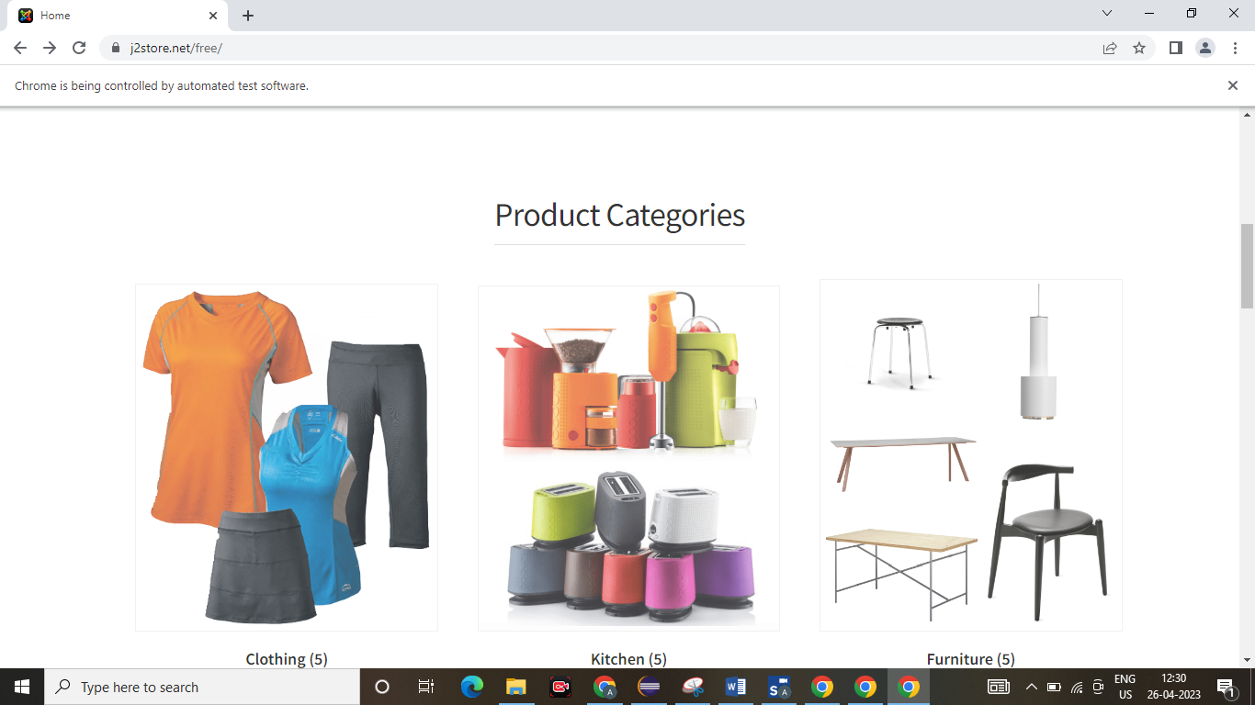

Task5.2

package day4;

import java.util.List;

import org.openqa.selenium.By;

import org.openqa.selenium.JavascriptExecutor;

import org.openqa.selenium.WebDriver;

import org.openqa.selenium.WebElement;

import org.openqa.selenium.chrome.ChromeDriver;

import org.openqa.selenium.chrome.ChromeOptions;

import io.github.bonigarcia.wdm.WebDriverManager;

public class task52{

public static void main(String[] args) throws InterruptedException {

// TODO Auto-generated method stub

// WebDriverManager.chromedriver().setup();

System.setProperty("webdriver.chrome.driver","C:\\drivers\\chromedriver.exe");

ChromeOptions co=new ChromeOptions();

co.addArguments("--remote-allow-origins=*");

WebDriver driver=new ChromeDriver(co);

driver.get("https://j2store.net/free/");

driver.manage().window().maximize();

JavascriptExecutor js=(JavascriptExecutor)driver;

js.executeScript("window.scrollBy(0,1000)", "");

driver.findElement(By.linkText("Clothing (5)")).click();

Thread.sleep(5000);

List<WebElement> l1=driver.findElements(By.xpath("//h2[@class='product-title']"));

for(WebElement link:l1){

System.out.println(link.getText());

}

}

}

Output:

